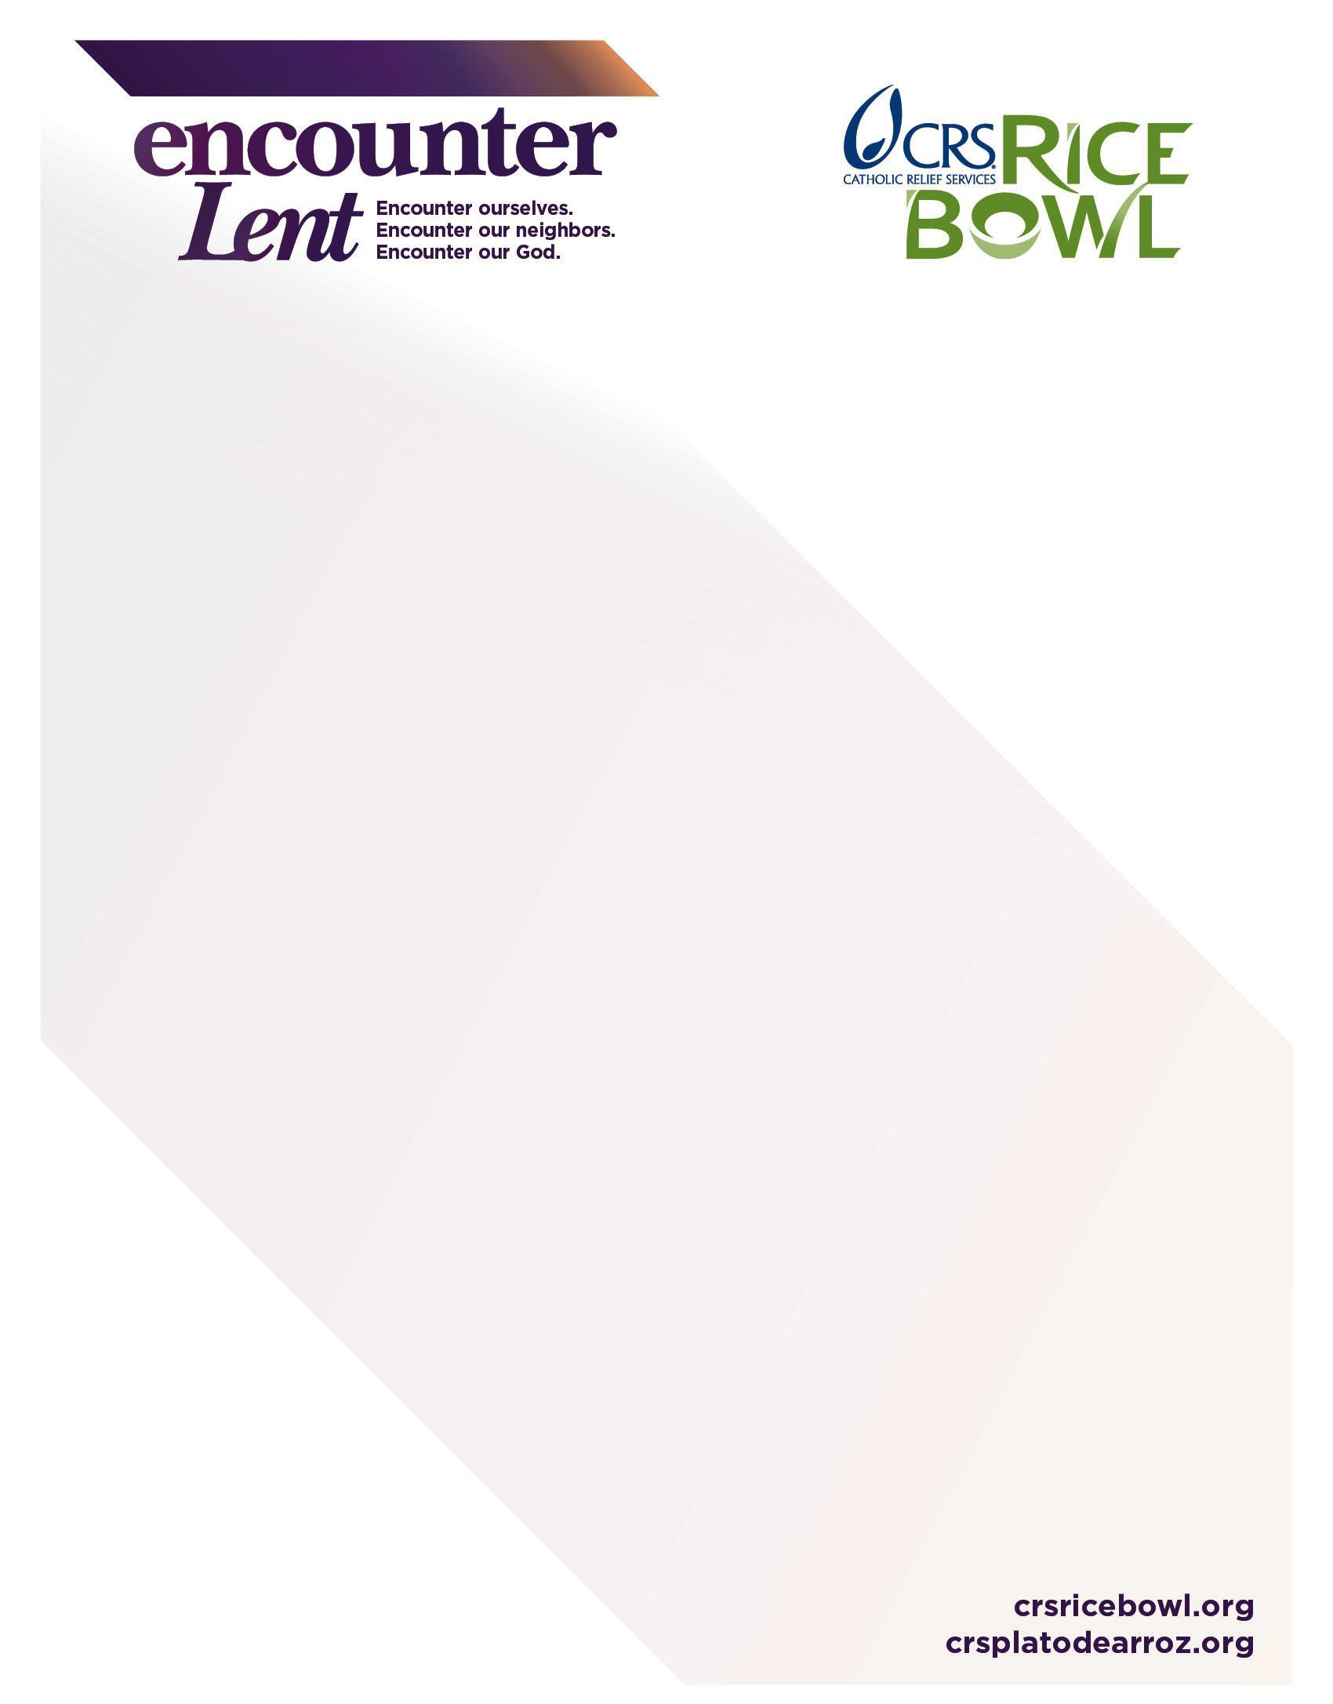

Sunday, Feb. 11 | First Sunday of Sawma
Monday, Feb. 12 | First DAY of Sawma
Sunday, Feb. 18 | Second Sunday of Sawma
 | THE GREAT FAST BEGINS
February 18-24 | IRAQ – Life and Dignity of the Human Person
Sunday, Feb. 25 | Third Sunday of Sawma
February 25 – March 3 | Nicaragua –Dignity of Work and Rights of Workers
Sunday, March 4 | Fourth Sunday of Sawma
March 4-10 | Burkina Faso – Care of God’s Creation
Sunday, March 11 | Fifth Sunday of Sawma
March 11-17 | Haiti – Call to Family, Community and Participation
Sunday, March 18 | Sixth Sunday of Sawma
March 18-24 | Malawi – Option for the Poor and Vulnerable
Sunday, March 25 | Seventh Sunday of Sawma (Palm Sunday)
March 26-31 | GREAT and HOLY WEEK
 | United States – Solidarity with our local community
March 29 | Passover Eve
March 30 | Passion Friday
March 31 | Saturday of Light
April 1 | GREAT SUNDAY OF THE RESURRECTION/EASTER

2018 CRS Rice Bowl
Chaldean Catholic Church Lenten Calendar

