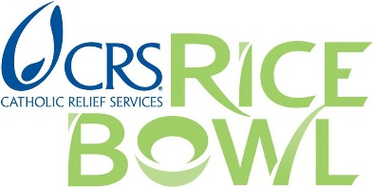
FOR IMMEDIATE RELEASE

CONTACT: Susan Gossling Walters
(443) 955-7103
susan.walters@crs.org

Make Meatless Fridays Matter
Five Simple Recipes to Change the World this Lent

Baltimore, MD, January 12, 2017 – When Lent begins on March 1st many Catholics will make dietary sacrifices – no candy, no ice cream, and certainly no meat on Fridays.
Catholic Relief Services’ CRS Rice Bowl program has a way to make Lent’s five meatless Fridays more than a sacrifice, turning them into a way to express solidarity with people around the world who struggle to keep healthy food on their tables every day.
These are the people CRS serves with a wide variety of programs in 100 countries. Five of those countries have provided a collection of simple, easy-to-follow meatless recipes that appeal to cooks of all abilities. And each comes with a video story about a person who benefits from CRS programming. These illustrate the great strides being made to improve health, education and nutrition in poor, mostly rural communities – so cooks of all ages will get to know the special ingredients that go into making the world a better place.
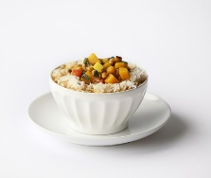
This year’s weekly Lenten features are:

Week 1: Story from the Singh Family from East India
Serve this simple meal from India: Dalma with spinach/Vegetable stew.

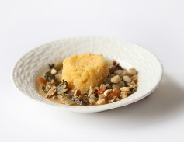
Week 2: Story from Evelina from Zambia
Serve this simple meal from Zambia: Ifisashi/Peanut stew over polenta.

Week 3: Story from Fernando from El Salvador
Serve this simple meal from El Salvador: Pupusas with cheese/Cheese stuffed tortillas.

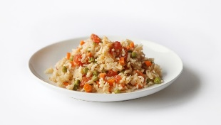

Week 4: Story from Maria from Mexico
Serve this simple meal from Mexico: Arroz rojo/Red rice.
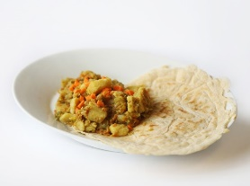

Week 5: Story Dita from Ethiopia
Serve this simple meal from Ethiopia: Injera with atkilt wat/Cabbage with crepes.

The CRS Rice Bowl recipes give you a way to look beyond macaroni and cheese and fried fish this Lent and turn meatless Fridays into a delicious and unique experience of solidarity with your global neighbors.
Since 1975, CRS Rice Bowl is the Lenten program used in more than 13,000 schools and parishes in every diocese in the United States. It is produced by one of the largest humanitarian aid agencies in the world, Catholic Relief Services which for 73 years has brought meaningful and measurable change to vulnerable communities around the world.
Find this year’s recipes and 18 others in a searchable collection on the CRS Rice Bowl website. (http://www.crsricebowl.org/recipe}

Editors, Reporters and Bloggers:
For recipe photos, FAQs, social media memes, web banners, please visit the CRS Rice Bowl Media Kit online or contact: Anna Ruiz anna.ruiz@crs.org or 410-951-7238

To be connected to local stories in your community, please contact Susan Walters susan.walters@crs.org

###

Catholic Relief Services is the official international humanitarian agency of the Catholic community in the United States. The agency alleviates suffering and provides assistance to people in need in more than 100 countries, without regard to race, religion or nationality. CRS’ relief and development work is accomplished through programs of emergency response, HIV, health, agriculture, education, microfinance and peacebuilding. For more information, visit www.crs.org or www.crsespanol.org and follow Catholic Relief Services on social media: Facebook, Twitter at @CatholicRelief and @CRSnews, Google+, Pinterest and YouTube.

