FOR IMMEDIATE RELEASE
CONTACT: Susan Gossling Walters
443-955-7103
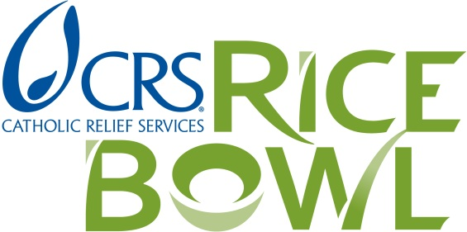
Susan.walters@crs.org

Tom Price
410-951-7450
Tom.price@crs.org

Five Family-Friendly Recipes for Lent
Use Alone or Combine with Stories of Hope, Videos and Prayer

Baltimore, MD, February 20, 2014 – CRS Rice Bowl, the Lenten program known for its colorful cardboard rice bowl and as a way to help transform the lives of those in need, features five new, easy-to-make meatless recipes. Originating from Kenya, Guatemala, the Philippines, Malawi and Haiti, the recipes present an opportunity for families to deepen their Lenten journey while exploring the world through new flavors. Each recipe comes with a story about a family that is on the road out of poverty, or like in the stories from the Philippines and Haiti, is on the road to recovery from a natural disaster.
Also new this year is a series of five cooking shows called CRS Rice Bowl’s Global Kitchen. Hosted by Fr. Leo Patalinghug from Grace Before Meals, the videos are a quick demonstration of how to cook each recipe and an introduction to the people and culture of each featured country.
“Lent is a time for us to come together as a global family and celebrate the gift of food. With CRS Rice Bowl we continue our Lenten traditions of prayer, fasting and almsgiving with recipes from five countries. They will inspire conversations around the table so we can understand what Lent means in our lives while getting to know our brothers and sisters in places like Kenya, Guatemala and my home country, the Philippines,” said Fr Leo Patalinghug.
CRS Rice Bowl’s Global Kitchen debuts on Catholic Relief Service’s YouTube channel and on crsricebowl.org/recipe-archive.
Using the recipes during Lent resonates with Pope Francis’ call to stop the blight of hunger and poverty around the world. He said, “the scandal that millions of people suffer from hunger must not paralyze us, but push each and every one of us to act: singles, families, communities, institutions, governments, to eliminate this injustice”.
“The recipes are an invitation for families and friends to have a meaningful experience during Lent. They make a concrete connection between our lives and the lives of others. By eating a meatless meal once a week during Lent we can contribute the savings to help change the lives of those who are hungry or in poverty,” said Joan Rosenhauer, executive vice president of U.S. Operations for CRS.
The recipes can be found at the CRS Rice Bowl website, crsricebowl.org or can be downloaded to a phone or tablet with the CRS Rice Bowl App. The free App is available from iTunes and Google Play Store or at crsricebowl.org/app
CRS Rice Bowl is in its 39th year, with millions of Catholics in 13,400 parishes and schools participating in the program. Last year, CRS Rice Bowl raised more than $7 million to support CRS programs overseas bringing sustainable solutions to fight poverty and hunger. Twenty-five percent of Rice Bowl donations remain in the dioceses where they are raised to address local needs.
For more information please visit, crsricebowl.org or see the online media kit.
###
Catholic Relief Services is the official international humanitarian agency of the Catholic community in the United States. The agency alleviates suffering and provides assistance to people in need in 91 countries, without regard to race, religion or nationality. For more information, please visit www.crs.org or www.crsespanol.org and follow CRS on Twitter @CatholicRelief and @CRS_expertise; and youtube.com/user/CatholicRelief.

