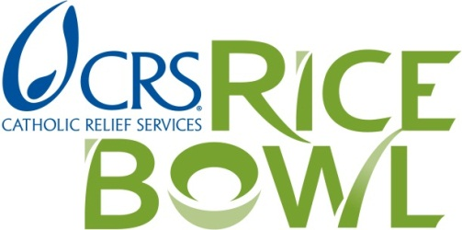
CRS Rice Bowl 2014 Collection Transmittal Form

Please take a few minutes to fill out this form for your (arch)diocese. In order to be recognized in the FY14 CRS Financial Statements, you must return this form with your (arch)diocesan contribution by September 1, 2014. If you have any questions, please contact crsricebowl@crs.org

Please be sure to complete both PAGES 1 and 2. Thank you!

- (Arch)diocese of ___________________________________________________________

- Name of Diocesan Director/Rice Bowl Coordinator: _____________________________

Mailing Address: ___________________________________________________________

Email Address: _____________________________________________________________

Phone Number: ____________________________________________________________

- Number of groups remitting Rice Bowl gifts to the (Arch)diocese: _________

4. Revenue Report
Please fill in the chart below with the results of your CRS Rice Bowl revenue collection for 2014.

25% retained by (Arch)diocese for local hunger and poverty alleviation efforts |  | $
75% to be sent to CRS by September 1, 2014 | Amount already remitted  (If you have already remitted a partial or full contribution, please indicate that amount here) | $
 | Amount enclosed | $
Total |  | $

Please make check payable to Catholic Relief Services – CRS Rice Bowl

Please remit to:
Catholic Relief Services
ATTN: CRS Rice Bowl
P.O. Box 17090
Baltimore, Maryland 21297-0303

PLEASE COMPLETE PAGE 2 AS WELL

- Payment Information – Required to receive local 25% from CRS
Since its inception, 25% of all funds generated through CRS Rice Bowl have remained in the local community in which they were raised. In that spirit, Catholic Relief Services is committed to ensuring that each diocese receives 25% of every contribution made to CRS Rice Bowl by its participating members. Dioceses should keep 25% of the Rice Bowl funds collected by their office and return 75% to CRS. In turn, CRS will return 25% of all contributions sent directly to CRS HQ to the respective diocese and keep 75%. In order to receive the outstanding portion of your diocese’s local 25%, you must fill out the following Payment Information Request form. Please remember that the local 25% of CRS Rice Bowl donations should be used to fund local hunger and poverty alleviation projects. If you have any questions, contact crsricebowl@crs.org.

Payment Information Request

Pay To The Order Of: ____________________________________________________________________
(Please print name)

Care of / contact name*: _________________________________________________________________

Address: _______________________________________________________________________________

City: ______________________________ State: ____________________ Zip: ______________

ABA Number: _________________________________________________________________________

Account name: _________________________________________________________________________

Account number: _______________________________________________________________________

Taxpayer Identification Number (TIN)*

______________________________

*If applicable

Email address for payment notification _____________________________________________________

- How does the (Arch)diocese use the local 25% of CRS Rice Bowl funds?
  - Grant to local St. Vincent de Paul chapters
  - Grant to local Catholic Charities projects
  - Other ______________________________________________________________________

Please explain:

By signing below, I acknowledge that my diocese has kept 25% of funds raised through CRS Rice Bowl to be used for local hunger and homelessness alleviation projects.

Signature: _____________________________________ Date: ___________________________

Thank you for all that you do to support CRS Rice Bowl and Catholic Relief Services!

